Middleware: Ludo game

Group 4

Jean Chan  
Loic Motheu  
Hristo Tarnev

User requirements specifications

Contents

Game description 3

Game rules 3

List of requirements 4

Functional requirements 4

Use case diagram 4

Use cases 5

User interface 10

Non-functional requirements 12

Glossary 13

# Game description

The game we chose is called Ludo. It is played by at most 4 people and at least 2. At the beginning of the game, each player's tokens are out of play and staged in one of the large corner areas of the board in the player's color. Each player then rolls the dice and the highest roller begins the game. The players alternate turns in a clockwise direction. To enter a token into play from its staging area to its starting square, a player must roll a 6. If the player has no tokens yet in play and does not roll a 6, the turn passes to the next player.

Special areas of the board are typically colored bright yellow, green, red, and blue. Each player is assigned a color and has four tokens of matching color.

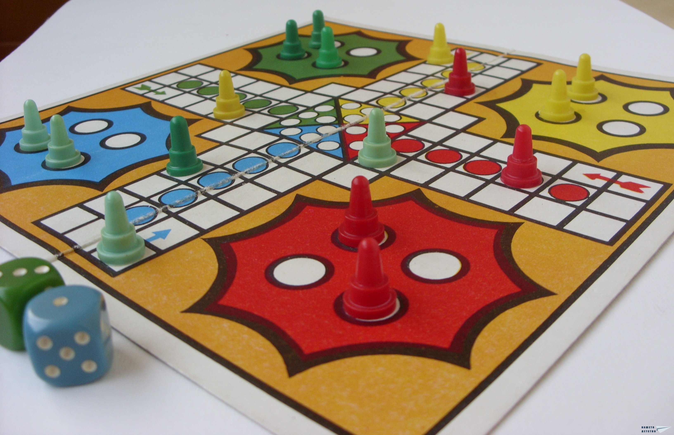

## Game rules

When able to, the players will enter their tokens one per time on their respective starting squares, and proceed to race them clockwise around the board along the game track. When reaching the square below his home column, a player continues by racing tokens up the column to the finishing square. The first to bring all their tokens to the finish wins the game.

When a player rolls a 6 he may choose to advance a token already in play, or alternatively, he may enter another staged token to its starting square. The rolling of a 6 earns the player an additional ("bonus") roll in that turn. If the additional roll results in a 6 again, the player earns an additional bonus roll. If the third roll is also a 6, the player may not move a token and the turn immediately passes to the next player. If the advance of a token ends on a square occupied by an opponent’s token, the opponent token is returned to its owner's yard, unless there is more than one token on that square. If it ends on a square with your token, you can stack up the tokens on one square. This may occur for all 4 tokens.

# List of requirements

|  |  |  |
| --- | --- | --- |
| **Number:** | **Description** | **MoSCoW** |
| 1 | An option to register through a portal | M |
| 2 | The player logs in using an existing username and password. | M |
| 3 | Player would click on the dice to roll it. | M |
| 4 | After a roll, the player will click on the desired moveable token and it will move automatically | M |
| 5 | Player chooses to place a token into play | M |
| 6 | Players have the option to speak publically to other players | S |
| 7 | Players have the option to chat privately with each other | S |
| 8 | Bot which would report the moves (In case someone goes away from keyboard) | S |
| 9 | The players have the possibility when registering to add an avatar | C |
| 10 | Host a game lobby | M |
| 11 | Invite players to a game lobby | S |
| 12 | Players can join a lobby | S |
| 12 | The ability to spectate a game | S |
| 14 | Leave a game | S |
| 15 | The system notifies the player at the moment the opponent's connection is lost. | C |

# Functional requirements

## Use case diagram

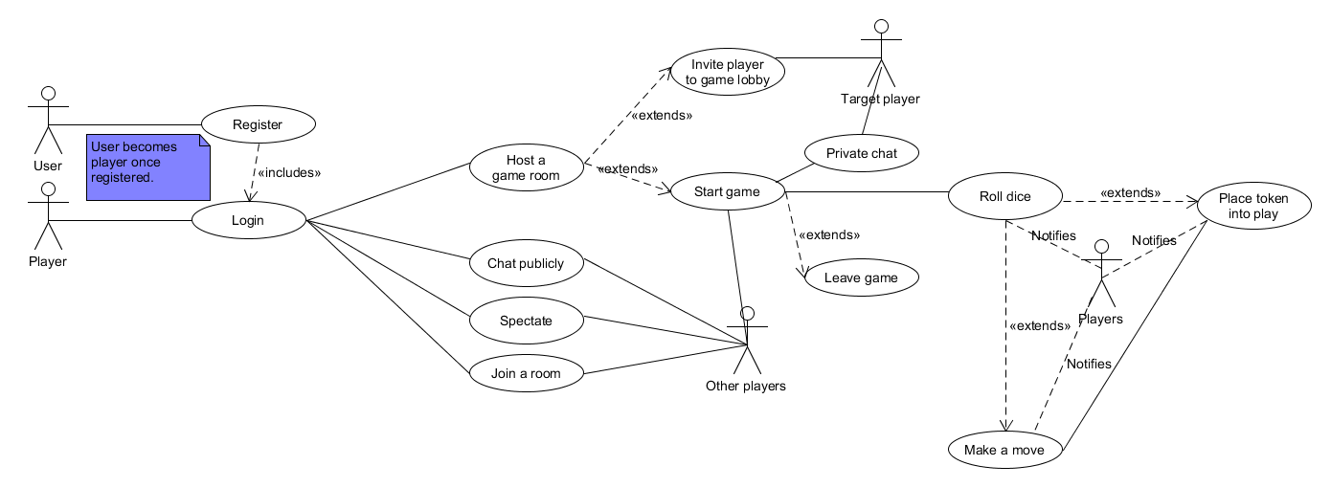

## Use cases

|  |  |
| --- | --- |
| *Goal* | *Make one move* |
| *Pre-condition* | *There is a token of that player in play* |
| *Trigger* | *Turn is up* |
| *Actor* | *Player* |
| *MSS* | 1. *Player clicks on desired token in play* 2. *System advances X number of squares (where X is the number on the dice) with that token.* |
| *Extension* | 1. *There already exists a token of the same color on that square (user can choose to stack the tokens).* 2. *There already exists a token of a different color on that square (the user of that token has to place it back in the “Home” area).* 3. There already exists two tokens from a different color on that square (the user can't place a token into play!) |
| *Rule* | *If the player rolls a 6 in stage one of the MSS, he can choose to insert a new token (if available) into play, then restarts the use case.* |
| *Post condition* | The token has moved. |

|  |  |
| --- | --- |
| *Goal* | Log in |
| *Pre-condition* | User must be registered and at the portal screen. |
| *Trigger* | Player wants to enter a game |
| *Actor* | Player |
| *MSS* | 1. Player enters personal information (email, password) and clicks submit. |
| *Extension* | 1. Information provided is incorrect, please try again. |
| *Rule* | User must be registered. |
| *Post condition* | Player is in the lobby. |

|  |  |
| --- | --- |
| *Goal* | Chat with another Player privately |
| *Pre-condition* | Player is logged in and at the lobby/in a game |
| *Trigger* | Button click on the chat icon of the target Player |
| *Actor* | Player, Target Player |
| *MSS* | 1. Player clicks on the chat button of the player he wants to chat with. 2. Player enters a message and sends it to the target Player. 3. Target Player receives the message. |
| *Extension* | 1. Error: Message was not sent (no internet connection). |
| *Rule* | The target Player must be logged in. |
| *Post condition* | Target Player has received the message and can now view it. |

|  |  |
| --- | --- |
| *Goal* | Join room |
| *Pre-condition* | Player must be logged in and at the Join tab-page. |
| *Trigger* | Button click |
| *Actor* | Player |
| *MSS* | 1. Player selects a room by clicking on it. 2. Player joins a room |
| *Extension* | 1. Room is full at the moment the player tries to join, player is redirected to Join tab-page. |
| *Rule* | There must be an available room to join. |
| *Post condition* | A game can be created. |

|  |  |
| --- | --- |
| *Goal* | *Put token into play* |
| *Pre-condition* | *Turn is up* |
| *Trigger* | *Must roll a 6* |
| *Actor* | *Player* |
| *MSS* | *1. The player clicks on desired token in base*  *2. System places selected token at start position* |
| *Extension* | *2.1 There already exists a token of the same color on that square (user can choose to stack the tokens).*  *2.2 There already exists a token of a different color on that square (the user of that token has to place it back in the “Home” area).*  *2.3 There already exists two tokens from a different color on that square (the user can't place a token into play!).* |
| *Rule* |  |
| *Post condition* | The token has been put into play. |

|  |  |
| --- | --- |
| *Goal -level* | *Spectate a game* |
| *Pre-condition* | *There is a game in the spectator tab running* |
| *Trigger* | User chooses game to spectate |
| *Actor* | *Spectator* |
| *MSS* | *1. User clicks on desired game in play to spectate*  *2. System gathers game information and joins it, user would have no control other than watching.* |
| *Extension* | *1a) Service is down, spectator cannot join and is notified* |
| *Post condition* | Spectator is watching the game |

|  |  |
| --- | --- |
| *Goal* | *Register* |
| *Pre-condition* | *Application is running, on portal page* |
| *Trigger* | User has clicked on register button. |
| *Actor* | *User* |
| *MSS* | *1. The user fills in the required fields and submits*  *2. System displays whether user is registered or not* |
| *Extension* | *2a) Username already exists, so the user would have to pick something different, the system notifies this.*  *2b) Network error.* |
| *Rule* | Usernames must be unique. |
| *Post condition* | A user has registered successfully as a player |

|  |  |
| --- | --- |
| *Goal* | *Host a game room* |
| *Pre-condition* | *Application is running in the lobby* |
| *Trigger* |  |
| *Actor* | *Player* |
| *MSS* | *1. The player navigates to the host tab and clicks on an empty room*  *2. Player may invite other players to play, remaining spots will not play, and game is ready to be launched.* |
| *Extension* | *2a) All rooms are full and the system cannot handle more rooms.* |
| *Rule* | A game needs a minimum of two players. |
| *Post condition* | The player has hosted a game lobby |

|  |  |
| --- | --- |
| *Goal* | *Roll the dice* |
| *Pre-condition* | *It must be the user’s turn* |
| *Trigger* | *Turn is up* |
| *Actor* | *User* |
| *MSS* | *1. Player clicks on the dice to roll the dice* |
| *Extension* |  |
| *Rule* | *If the player rolls a 6, the user may roll once more after he/she has made his/her move* |
| *Post condition* | The dice shows the number that the user rolled |

|  |  |
| --- | --- |
| *Goal* | *Chat in a public room* |
| *Pre-condition* | *Player is logged in and at the lobby/in a game* |
| *Trigger* | *Logging in to the lobby/ to a game* |
| *Actor* | *Player, Other players* |
| *MSS* | 1. Player enters a message and sends it to the target Player. 2. Other player receives the message. |
| *Extension* | *2.2 Error: Message was not sent (no internet connection).* |
| *Rule* |  |
| *Post condition* | *Other players receive the message and can now view it* |

|  |  |
| --- | --- |
| *Goal* | *Invite player to a game lobby* |
| *Pre-condition* | *Player is hosting a game lobby* |
| *Trigger* | Button click on the plus icon of the target Player |
| *Actor* | *User, Target player* |
| *MSS* | *1. Player clicks on the plus button of the player he wants to the game lobby.*  *2. Target player receives an invitation to the game lobby.* |
| *Extension* | *1.1* Error: Invitation was not sent (no internet connection). |
| *Rule* | The target Player must be logged in. |
| *Post condition* | Target Player has received the invitation and can now either accept or decline the invitation. |

|  |  |
| --- | --- |
| *Goal* | *Player leaves the game* |
| *Pre-condition* | *Player is currently in a game* |
| *Trigger* | Button click on the leave game button |
| *Actor* | *Player* |
| *MSS* | *1. Player clicks on the “Leave Game” button.*  *2. Player will surrender the game and leaves the game and returns to the lobby.* |
| *Extension* |  |
| *Rule* |  |
| *Post condition* | Player is returned to the lobby |

# User interface

This is the first version of the User interface

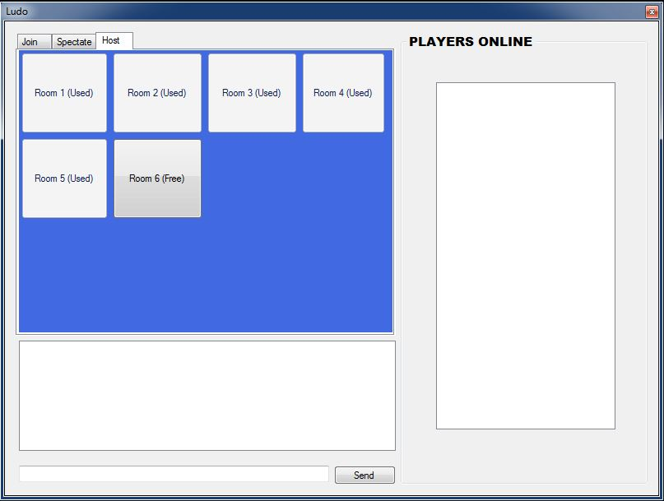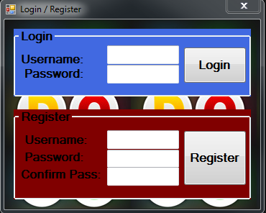

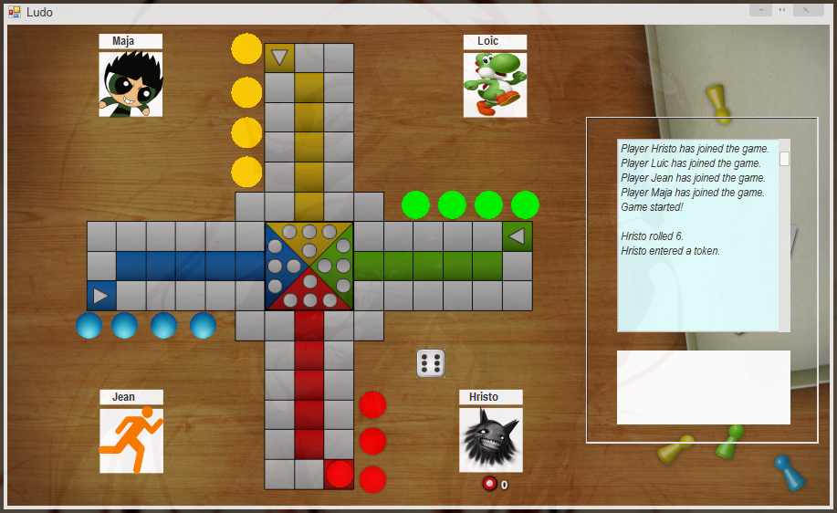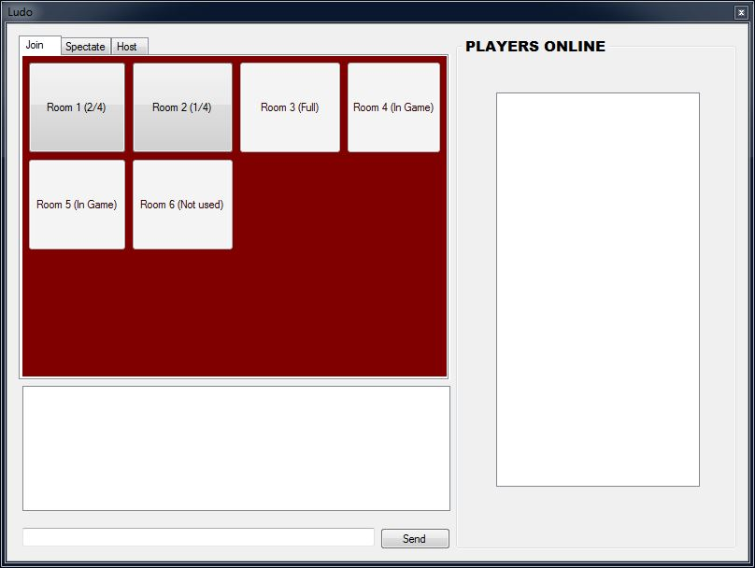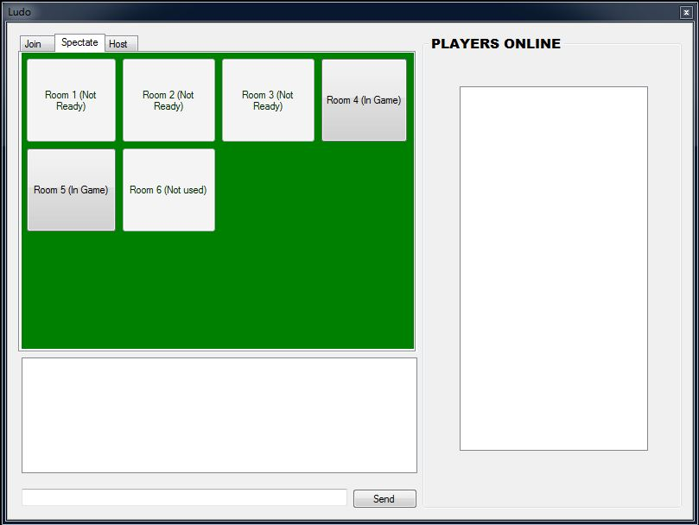

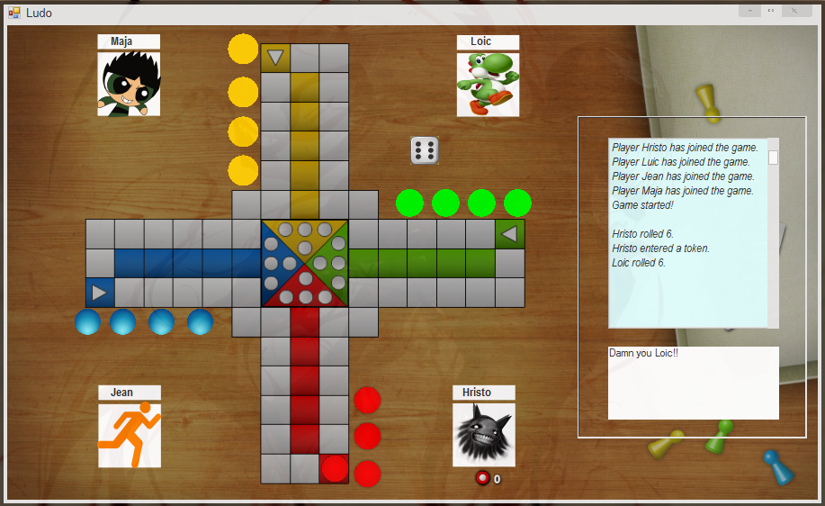

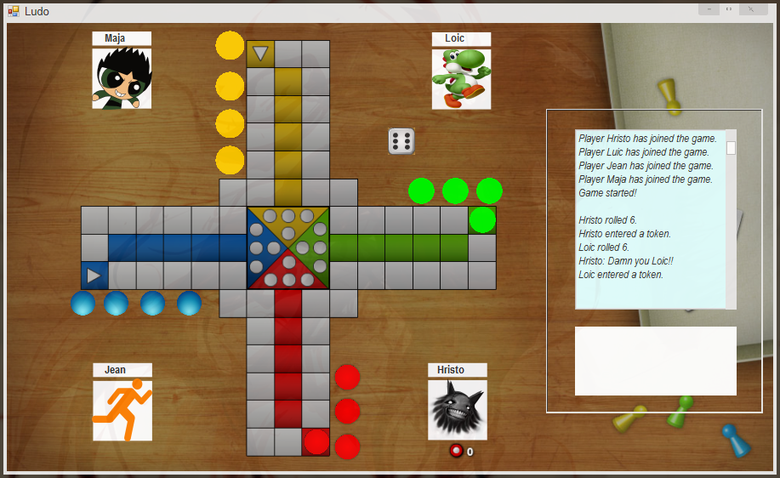

# Non-functional requirements

* Will run on windows 7, 8, 10
* Requires an internet connection
* Fixed window size
* 2-4 players

# Glossary

User: Someone using the application that did not register into a player yet.

Player: A user who has registered for the game.

Spectator: Someone who can only watch the game, has no interaction whatsoever.

Lobby: Is the application which allows players to host, join and spectate rooms.

Room: Can be joined from the lobby, can contain up to 4 players along with spectators, can start the game.

Game: Is played by 2-4 players and can be spectated.